CREATIVE EDUCATIONAL SERVICES

**P.7 PRE-MOCK EXAMINATIONS 2024**

**SOCIAL STUDIES & RELIGIOUS EDUCATION**

***Time allowed: 2 Hours 15 Minutes***



**Candidate’s Name: __________________________________________________**

**Candidate’s Signature: _______________________ Date: __________________**

**School’s EMIS Number: ______________________________________________**

**District Name: _____________________________________________________**

**Read the following instructions carefully**

1. The paper has two sections: A and B.
2. All the working for both sections A and B must be shown in the spaces provided.
3. All working must be done using a blue or black ball – point pen or fountain pen. Diagrams must be drawn in pencil.
4. Un necessary changes of work may lead to loss of marks.
5. Any handwriting that cannot easily be read may lead to loss of marks.
6. Do not fill anything in boxes indicated: **“For Examiners’ Use Only**: and those inside the question paper

|  |  |
| --- | --- |
| **SECTIONS** | **MARKS** |
| **SECTION A** |  |
| **SECTION B** |  |
| **TOTAL** |  |

**SECTION A**

1. Name the land form that covers the largest part of Uganda.

________________________________________________________________

1. Ntuyo saw the wind vane pointing towards the west. To which direction was the wind blowing?

________________________________________________________________

1. Name the country that lies to the north of Sudan.

________________________________________________________________

1. Mention any one of the children’s rights that promote good health.

________________________________________________________________

1. Sate any one way in which the government of Uganda can provide safe water to citizens.

________________________________________________________________

1. Mention any one member of an extended family.

________________________________________________________________

1. Mention any one means of transport that is good for carrying perishable goods over long distances.

_______________________________________________________________

1. How did Ethiopia become a landlocked country?

________________________________________________________________

1. Write UNHCR in full.

________________________________________________________________

1. Give any one advantage of multiparty system of governance.

________________________________________________________________

1. What is meant by population census?

________________________________________________________________

1. It is 7:00am at a place which is 300 East of the Prime Meridian. What time will it be at a place which is 150 East?

________________________________________________________________

1. Give any one source of government revenue.

________________________________________________________________

1. What contribution did Kabaka Mutesa I make towards Christianity in Uganda?

________________________________________________________________

1. On which river in Africa is the Akasombo dam built?

________________________________________________________________

1. Why did MAU MAU rebellion take long to end?

________________________________________________________________

1. Give any one advantage of carrying out irrigation on a large –scale than depending on rainfall.

________________________________________________________________

1. Why is it important for Uganda to have a national language?

________________________________________________________________

1. State any one importance of trees in a school compound.

________________________________________________________________

1. Mention any one feature on the Uganda coat of arms that represents culture.

________________________________________________________________

1. How is a kitchen useful at home?

________________________________________________________________

1. Give any one duty of the judiciary.

________________________________________________________________

1. Why is land considered to be the most important resource?

________________________________________________________________

1. State any one reason why some people in Uganda fail to get access to social services.

________________________________________________________________

1. Which political party led Uganda to independence? ________________________________________________________________
2. Give any one contribution of Dr. Albert Cook to the health service in Uganda.

________________________________________________________________

1. Give one factor that led to the growth and expansion of Buganda Kingdom.

________________________________________________________________

1. State any one reason why it is difficult to carry out mechanized agriculture in Kapchorwa District.

________________________________________________________________

1. Mention any one similar cultural practice among the Bagisu and the Bakonjo.

________________________________________________________________

1. Why did Belgium take over Rwanda after the First World War?

________________________________________________________________

1. Mention any one material from the environment that can be used to make pots.

________________________________________________________________

1. How was the building of the Uganda Railway useful to the colonialists?

________________________________________________________________

1. State any one problem faced by the national Environment Management Authority (NEMA) as it carries out its duties.

________________________________________________________________

1. State any one local method of preserving fish.

________________________________________________________________

1. Give any one cause of road accidents.

________________________________________________________________

**For questions 36 – 40, answer Either Christianity or Islamic but not both.**

1. Either: Why shouldn’t Christians fear death?

________________________________________________________________

Or: Why shouldn’t Moslems fear death?

________________________________________________________________

1. Either: Give any one way in which Christians communicate to God.

________________________________________________________________

Or: Give any one way in which Muslims communicate to Allah.

________________________________________________________________

1. Either: Why is Angel Gabriel important in Christianity?

________________________________________________________________

Or: Why is Angel Jibril important in Islam?

________________________________________________________________

1. Either: What did Jesus Christ teach about the poor?

________________________________________________________________

Or: What did Prophet Muhammad teach about the poor?

________________________________________________________________

1. Either: What is the value of Easter Sunday?

________________________________________________________________

Or: What is the value of Idd – el – Fitr?

________________________________________________________________

**SECTION B**

1. a) Mention any two means of water transport used in East Africa.
2. ___________________________________________________________
3. ___________________________________________________________

b) Give any two reasons why water transport is not possible on some rivers.

i) ______________________________________________________________

ii) ______________________________________________________________

1. a) What is meant by plantation farming?

________________________________________________________________

b) State any two importance of farming to the economic development of Uganda.

i) ______________________________________________________________

ii) ______________________________________________________________

c) How can dairy farming be improved in Uganda?

________________________________________________________________

1. a) Why did the British use indirect rule in Uganda?

________________________________________________________________

b) State any two methods that were used by the Europeans to get colonies in Africa.

i) ______________________________________________________________

ii) ______________________________________________________________

c) What was meant by assimilation policy?

________________________________________________________________

1. Study the map of Africa below and answer the questions that follow.

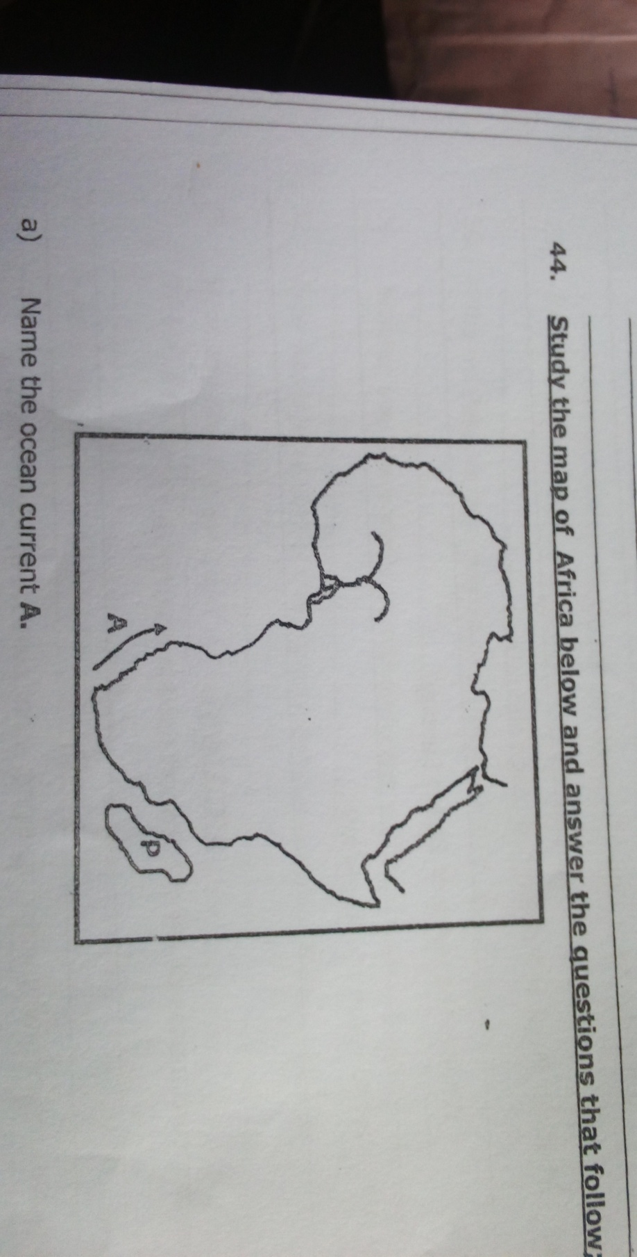

1. Name the ocean current A.

_____________________________________________________________

1. Use letter M to show the position of Mediterranean Sea.
2. Name the country P.

_____________________________________________________________

1. Why does River Congo carry the largest volume of water to the sea?

_____________________________________________________________

1. a) Name any two member countries of Economic Community of West African States. (ECOWAS).
2. ___________________________________________________________
3. ___________________________________________________________

b) Give any two reasons why the Economic Community of West African States was formed.

i) _____________________________________________________________

ii) ______________________________________________________________

1. Complete the table below.

|  |  |  |
| --- | --- | --- |
| Type of leaders | Example of leaders | How they get power |
| Political leader | LCV Chairperson | _________________ |
| ___________________ | Chief Administrative Officer (CAO) | ___________________ |
| Cultural leader | King | ___________________ |

1. a) Give any two ways in which a school benefits from the neighbourhood.
2. ___________________________________________________________
3. ___________________________________________________________

b) State any two causes of problems between a school and the neighbourhood.

i) ______________________________________________________________

ii) ______________________________________________________________

1. a) Give any two reasons why some areas in East Africa have higher population densities than others.
2. ___________________________________________________________
3. ___________________________________________________________

b) Mention any two problems faced by people in areas with high population densities.

i) ______________________________________________________________

ii) ______________________________________________________________

1. a) Name any two Bantu tribes that settled near lakes in Uganda.
2. ___________________________________________________________
3. ___________________________________________________________

b) Give any two factors that made the Bantu to settle in the lake regions of East Africa.

i) ______________________________________________________________

ii) ______________________________________________________________

1. Study the climatic graph below and answer the questions that follow:

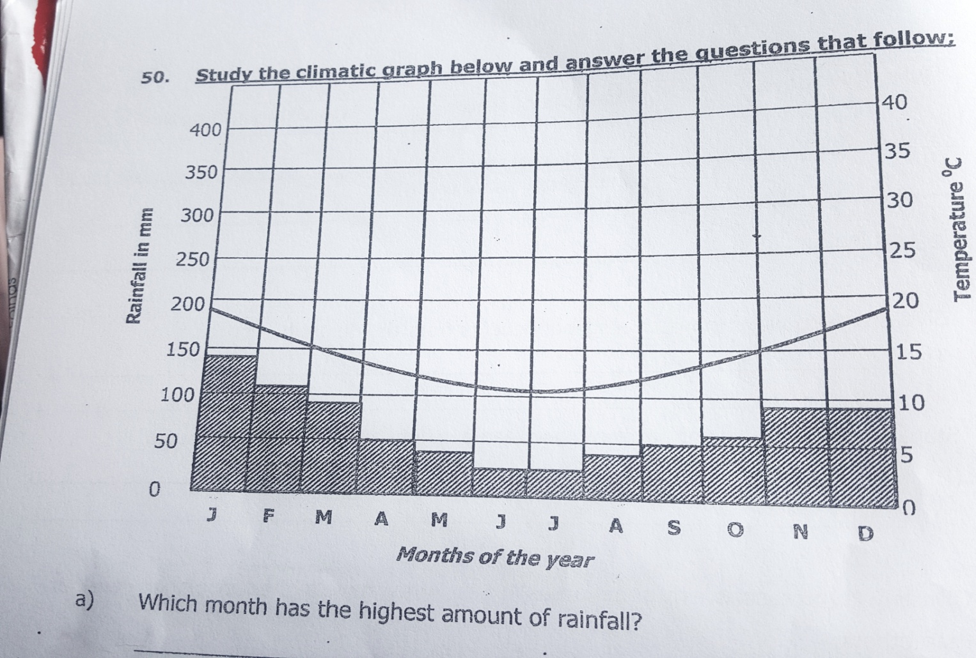

1. Which month has the highest amount of rainfall?

_____________________________________________________________

1. Name the type of climate experienced in the area above.

_____________________________________________________________

1. What is the relationship between rainfall and temperature?

_____________________________________________________________

1. Which month has the lowest temperature?

_____________________________________________________________

**For questions 51 – 55, answer Either Christianity or Islam but not BOTH.**

1. Either: a) According to the Christian faith, Give any two sacrament.
2. ___________________________________________________________
3. ___________________________________________________________

b) State any one role of a priest in the Christian churches.

________________________________________________________________

c) Give any one reason why Christians kneel down during prayer in the church.

________________________________________________________________

Or: a) According to the Islamic faith, who leads worshippers in the mosque?

______________________________________________________________

b) Give any two duties of an Imam in the Islamic faith.

i) _____________________________________________________________

ii) ______________________________________________________________

c) Give one reason why Moslems kneel down during prayers.

________________________________________________________________

1. Either: a) What is Holy Matrimony?

_______________________________________________________________

b) Mention any two things that can stop Holy Matrimony from taking place.

i) ______________________________________________________________

ii) ______________________________________________________________

c) Give any one advantage of Holy Matrimony.

________________________________________________________________

Or: a) What is Nikkah?

________________________________________________________________

b) Mention any two things that can stop Nikkah from taking place.

i) ______________________________________________________________

ii) ______________________________________________________________

c) Give any one advantage of Nikkah.

________________________________________________________________

1. Either: a) Name the man who helped Jesus Christ to carry the cross.

_______________________________________________________________

b) State any two ways in which a Christian child can help a friend who has fallen sick at school.

i) _____________________________________________________________

ii) ______________________________________________________________

c) Give any one reason why it is important to care for God’s creation.

_______________________________________________________________

Or: a) Name the cousin of Prophet Muhammad who became a caliph.

______________________________________________________________

b) State any two ways in which a Muslim child can help a friend who has fallen sick at school.

i) ______________________________________________________________

ii) ______________________________________________________________

c) Give any one reason why it is important to care for Allah’s creatures.

_______________________________________________________________

1. Either: a) Who built an ark according to the Bible?

________________________________________________________________

b) Why did he build the ark?

_______________________________________________________________

c) Mention any two lessons you learn from the story of the ark.

i) ______________________________________________________________

ii) ______________________________________________________________

Or: a) Who built an ark according to the Quran?

________________________________________________________________

b) Why did he build the ark?

________________________________________________________________

c) Mention any two lessons you learn from the story of the ark.

i) ______________________________________________________________

ii) ______________________________________________________________

1. Either:
2. State any two characteristics of African Traditional Religion.
3. ________________________________________________________
4. ________________________________________________________
5. Give any two similarities between African Traditional Religion and Christianity.
6. ________________________________________________________
7. ________________________________________________________

Or:

1. State any two characteristics of African Traditional Religion.
2. ________________________________________________________
3. ________________________________________________________
4. Give any two similarities between African Traditional Religion and Islam.
5. ________________________________________________________
6. ________________________________________________________

**END**